Multithreading (Java Concurrency)

- A process is an independent program in execution.

Multithreading:
- Thread is a smallest unit of a Process (program in execution) which can be referred as a program.
- Executing multiple threads simultaneously is called as multithreading.
- For each new thread, stack area will be created separately!! (one stack for one thread)

Real Time Example:
- A thread is like a worker in a restaurant (process).
- All workers share the same kitchen (memory/resources) where all the works(execution) is done.
- Each cook/Receptionist/Janitor (thread) handles one Task — cooking, billing, cleaning.

- Creating Threads in Java:

Using Thread class

Thread is a class in Java.
To create thread using Thread class:
- Extend Thread
- Override run()
- Call start()

Example 1 — Using Thread class
class MyThread extends Thread {
@Override
public void run() {
System.out.println("Thread is running");
}
}
public class Test {
public static void main(String[] args) {
MyThread t = new MyThread();
MyThread t2= new MyThread();
t.start(); // start thread
}
}
Output:
Thread is running

Method | Meaning
run() | normal method call
start() | creates new thread

Creating Thread using Runnable interface

- Runnable is a functional interface with single abstract method run(), which can be used to perform various tasks in multithreading.

public interface Runnable {
void run();
}
Steps:
- Implement Runnable
- Override run()
- Pass object to Thread
- Call start()

Example 2 — Using Runnable
class MyRunnable implements Runnable {
@Override
public void run() {
System.out.println("Thread running using Runnable");
}
}
public class Test {
public static void main(String[] args) {
MyRunnable r = new MyRunnable();
Thread t = new Thread(r);
t.start();
}
}
Output:
Thread running using Runnable

Why Runnable is preferred?

Because Java supports only single inheritance.
If you extend Thread → cannot extend another class.
class A extends Thread ❌ cannot extend another class

But with Runnable:
class A extends Car implements Runnable ✅ allowed
So Runnable is more flexible.

- Thread is an implementing class(Child) of Runnable Interface!

Methods of Thread Class
- run () :
It is an abstract method present inside a Runnable interface and implemented in Thread Class.

It contains the code we want to execute in a thread.
This method is called by the thread when it executes.
Calling this method will:
- This just calls the method like a regular function.
- It does not create a new thread.
- It runs on the main thread, not in parallel.
i.e main thread will end only after executing these the other Threads executed by run()

- start () :
It is a non-static method present inside a Thread class.

Causes this(current) thread to begin execution; the Java Virtual Machine internally calls the run() method of this(current) thread.
It starts a new thread. It internally calls the run() method, but in a new thread.
run() runs in a new thread, in parallel with the main thread.

i.e main thread and this thread execution are independent of each other

- All the Threads will run concurrently independent of each other!!

- Thread.currentThread()

Returns the Thread object for the current thread

e.g. Thread[#22,Negative Number,5,main]

- #22: Thread id
- Negative Number: Thread Name
- 5: Priority
- main : Thread group

- Thread.sleep()

pauses the execution of the current thread for a specified duration (in milliseconds)

Properties of a thread:
- Id :
- The id of a thread is given by the JVM. We can fetch this property using a method called as threadId(),

- Name :
- Name property is modifiable i.e. we can change the name of a thread using setName(String name).
- We can fetch the name of the thread using getName().

- Priority :
- A newly created thread will have the priority as 5 by default, the minimum priority can be 1 and maximum priority can be 10.
- We can set the priority value using setPriority(int priority), we can fetch the priority value using getPriority().

Note:
- Thread priorities are hints to the thread scheduler, not guarantees.
- On some systems (like Windows/Linux), the JVM might ignore priorities or treat them differently based on the OS scheduling policy.
- It cannot guarantee the preferences but may increase the chance.

Problems with older approach:

- Creating a new thread is expensive.
- Too many threads can consume large amounts of memory.
- Thread lifecycle management becomes difficult.
- No thread reuse.
- Hard to handle thousands of concurrent tasks.

Modern Alternative: Executor Framework

- Instead of creating Threads manually, we will be submitting tasks to a thread pool.

- Executor Framework will manage the Thread creation and usage as per requirement.

- Using ExecutorService and Executors

- ExecutorService is a Java interface used to manage and control threads.
Instead of creating threads manually (new Thread()), we can submit tasks, and the ExecutorService:
- creates threads
- reuses threads
- manages their lifecycle
- executes tasks efficiently

Think of it as a thread manager.

- Problems with manual thread creation:
- Creating too many threads → performance issues
- No control over thread lifecycle
- Hard to manage errors and shutdown

ExecutorService solves this by:
- Reusing threads (thread pool)
- Limiting number of threads
- Improving performance
- Making code cleaner and safer

It is an Industry standard way of doing multithreading in Java.

- Executors is a utility class that provides factory methods to create ExecutorService objects.

- They provide ready-made thread pool types and makes code simple and readable.

1. newSingleThreadExecutor()
- Only one thread
- Tasks execute one by one
- Maintains order

ExecutorService executor = Executors.newSingleThreadExecutor();

2. newFixedThreadPool(n)
- Fixed number of threads
- Tasks are aligned in queue if threads are busy

ExecutorService executor = Executors.newFixedThreadPool(3);

3. newCachedThreadPool()
- Creates threads as needed
- Reuses idle threads
- No upper limit like newFixedThreadPool

ExecutorService executor = Executors.newCachedThreadPool();

4. newVirtualThreadPerTaskExecutor() (Java 21+)
- Lightweight virtual threads
- Highly scalable

ExecutorService executor =
Executors.newVirtualThreadPerTaskExecutor();

- Runnable is a functional interface i.e it has only one abstract method run().

It is used to define a task that:
Does NOT return a value

e.g:
Runnable task =
() -> {
System.out.println("Task running");
};

- Callable is a functional interface having one abstract method call()

It is also used to define a task but:
Returns a value

e.g.
Callable<Double> call=
()->{
return Math.random();
};

These interfaces can be used to provide implementation of any task!

- execute()

- Used to submit a Runnable and execute it
- Does not return anything
e.g:
executor.execute(() -> {
System.out.println("Using execute()");
});

- submit()

- Used to submit Runnable OR Callable
- Returns a Future

e.g.
executor.submit(
()->{
return Math.random();
};
)

To print the result:
System.out.println(e.submit(
()->{
return Math.random();
}
).get()
);

- Each new thread will have a dedicated stack memory, where each and every thread will be executed independently

- Thread.sleep()

pauses the execution of the current thread for a specified duration (in milliseconds)

Synchronization in Multithreading:

Problem in Multithreading

- When multiple threads try to access a shared resource(single resource) simultaneously being unaware of each other’s operation on the shared resource, leads to data inconsistency or undesired output(race condition).

- This is because multiple threads will try to access a single resource, resulting in race conditions, both executing together without waiting for each other!!!

- The above problem in multithreading can be overcome using synchronization concept.

Synchronization:
- It is the process using which we can achieve data consistency(accuracy) in multithreaded environment. It can be achieved using synchronized keyword.

- It ensures that only one thread at a time can access the shared resource.

- In Java, synchronization can be achieved using the synchronized keyword.

- “synchronized” keyword can be used only with the blocks(methods or separate blocks).

- Whenever a thread gets an access to a synchronized shared resource then the lock will be applied on that resource so that no other thread can get access to same synchronized shared resource.

- This lock will not be released until and unless the currently executing thread (which has the access on the synchronized shared resource) completes its execution.

Working

- Whenever a thread gets access to a synchronized shared resource, a lock is applied to that resource.
- No other thread can access the same synchronized resource until the lock is released.
- The lock will not be released until the currently executing thread completes its execution of the synchronized block/method.

Types of Locks in Java
There are two types of locks:

1. Class Lock
- If the synchronized shared resource is static, then the lock applied is called a Class Lock.
- The lock is applied on the Class object (e.g., MyClass.class).
- Only one thread can execute any static synchronized method of that class at a time.

2. Object Lock
- If the synchronized shared resource is non-static, then the lock applied is called an Object Lock.
- The lock is applied on the current object (this).
- Multiple objects can have separate locks.

Synchronization Using ReentrantLock

ReentrantLock
- ReentrantLock is a class from the java.util.concurrent.locks package.
- It provides the same locking mechanism as synchronized, but with more flexibility and control.

It provides additional features such as:
- Manual lock and unlock control
- tryLock() – attempts to acquire lock without waiting indefinitely
- Timed lock – wait for a specific time

Deadlock in multithreading:
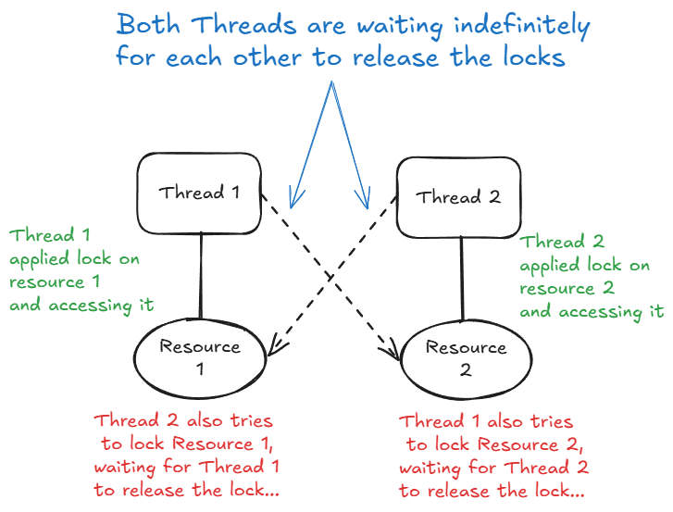

- In the given diagram, we are dealing with two threads and two shared resources, both of which are synchronized. Let’s denote them as:
- Threads: T1 and T2
- Resources: R1 and R2
Step 1: Thread T1 locks Resource R1
- Thread T1 starts its execution.
- It successfully acquires a lock on Resource R1.
- This means no other thread can access or lock R1 until T1 releases it.

Step 2: Thread T2 locks Resource R2
- At the same time, Thread T2 also starts executing.
- It successfully acquires a lock on Resource R2.
- Now, R2 is locked by T2, and any other thread (including T1) trying to access R2 will have to wait.

Step 3: Thread T1 tries to lock Resource R2
- After locking R1, Thread T1 attempts to lock R2.
- However, R2 is already locked by Thread T2.
- So, T1 is put on hold — it will wait until R2 is released.

Step 4: Thread T2 tries to lock Resource R1
- Similarly, after locking R2, Thread T2 attempts to acquire a lock on R1.
- But R1 is currently held by Thread T1.
- As a result, T2 is also put on hold, waiting for R1 to be released.

Step 5: The Deadlock
- Now, both threads are stuck:
  - T1 is waiting for T2 to release R2.
  - T2 is waiting for T1 to release R1.
- Neither thread can proceed because they are each holding one resource and waiting for the other.
- This results in a deadlock, where both threads are indefinitely waiting for each other to release the required locks!!!.

DeadLock Avoidance

1. Locking Resources in the Same Order

Rule:
Always acquire locks in a consistent global order.
Example:
Correct way:
synchronized(R1) {
synchronized(R2) {
// other logic
}
}
Every thread must follow:
First lock R1
Then lock R2

If all threads follow the same order:
Circular wait cannot occur → Deadlock eliminated.
This is the industry’s simplest and safest approach.

2. Using ReentrantLock
Instead of synchronized, we can use ReentrantLock, which provides more control.

- Here, a single shared lock will be used by multiple thread.

- One Thread can acquire this lock at a time rest of the threads will be waiting for some time until the acquired lock is released!

- So , a single lock can be shared between multiple threads in a synchronized manner.

Thread life Cycle :

- A programmer cannot control a thread life cycle; it is completely dependent on thread schedular.
- Following Factors which will be taken into consideration by the thread schedular to manage thread life cycle.

1.Sometimes thread schedular follows first come first serve principle.
2.The priority of a thread.
3.System configuration ( Operating System, Processor )

- The Thread Scheduler is a part of the Java Virtual Machine (JVM) that decides which thread to run next out of multiple threads.

- Thread Scheduler is like a traffic controller — it manages the flow of multiple threads trying to run on the CPU and picks one based on certain scheduling policies.

- Thread schedular will allocate the CPU to a thread for its execution for specific interval of time (not always).

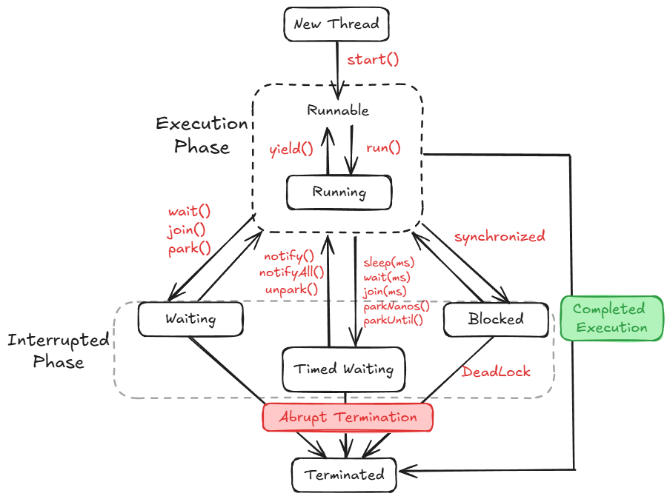

1. New Thread (New State)
- A thread object is created using new Thread(), but it hasn’t started yet.

2. Runnable State
- The thread is ready to run and is waiting for the Thread Scheduler to pick it up. It’s not running yet !.

3. Running State
- The thread is actively executing code in its run() method.
- How it gets here:
  - Thread Scheduler picks it from the Runnable queue.

4. Blocked State
- The thread is waiting to enter a synchronized block/method(Resource) locked by another thread.
- How it gets here:
  - Tries to enter synchronized code that's already locked.
- How it exits:
  - When the lock is released, it returns to Runnable.
- Special Case:
  - May lead to Deadlock if threads are stuck waiting on each other forever.

5. Waiting State
- The thread is waiting indefinitely for another thread waiting for Thread Schedular to pick them up again for execution.

6. Timed Waiting State
- The thread is waiting for a specific time (not indefinitely).
- How it gets here:
  - sleep(ms)
  - wait(ms)
  - join(ms)

7. Terminated (Dead) State
- The thread has completed execution or terminated abnormally.
- How it gets here:
  - run() completes successfully → Completed Execution
  - An exception or forced stop → Abrupt Termination

🔹 Abrupt Termination
- Thread is killed or stopped due to some problem or an unhandled exception, or external interrupt/kill.(using sleep() for long time, interrupt(), stop())
- Leads to:
Terminated state.

- Imagine a food delivery app like Swiggy:
- 🧾 Order created → New
- 🚴 Delivery person assigned → Runnable
- 🏍️ Out for delivery → Running
- 🚦 Stuck at red signal → Blocked
- ☕ Waiting at restaurant → Waiting
- ⏲️ Waiting for OTP → Timed Waiting
- ✅ Order delivered or canceled → Terminated

Daemon Threads :
- Daemon Threads are low priority threads which will be started by the JVM itself after regular interval of time.

- A programmer cannot control the execution of daemon threads. Along with that a programmer cannot see the execution of daemon threads.
- Daemon threads will be executed in the background during the run time of an application.

- We have some inbuilt Daemon Threads as well as a user can also define customized Daemon threads.

- The popular inbuilt daemon thread in java is Garbage Collector.

- Garbage collector is a program (Daemon Thread) which will be executed over a regular interval of time by the JVM to search for garbage (de-referred objects) inside the heap memory and removing them from the heap memory which leads to efficient utilization of the heap space.

